**TEHREEM IJAZ**

**62688**

**TASK NO 01**

#include <iostream>

#include <string>

using namespace std;

struct Product {

    int Code;

    string Description;

    char Packaging; // L, S, M

    float Price;

    float Discount; // Discount percentage

};

int main() {

    Product products[10] = {

        {1, "Product1", 'L', 500, 10},

        {2, "Product2", 'M', 300, 5},

        {3, "Product3", 'L', 1200, 15},

        {4, "Product4", 'S', 100, 0},

        {5, "Product5", 'L', 700, 20},

        {6, "Product6", 'L', 950, 5},

        {7, "Product7", 'M', 600, 10},

        {8, "Product8", 'L', 400, 0},

        {9, "Product9", 'L', 200, 10},

        {10, "Product10", 'S', 1000, 25}

    };

    cout << "Products with Large packaging and net price between 200-1000:" << endl;

    for (int i = 0; i < 10; i++) {

        if (products[i].Packaging == 'L') {

            float netPrice = products[i].Price * (1 - products[i].Discount / 100);

            if (netPrice >= 200 && netPrice <= 1000) {

                cout << "Code: " << products[i].Code

                     << ", Description: " << products[i].Description

                     << ", Price: $" << products[i].Price

                     << ", Discount: " << products[i].Discount << "%"

                     << ", Net Price: $" << netPrice << endl;

            }

        }

    }

    return 0;

}

**OUT PUT:**

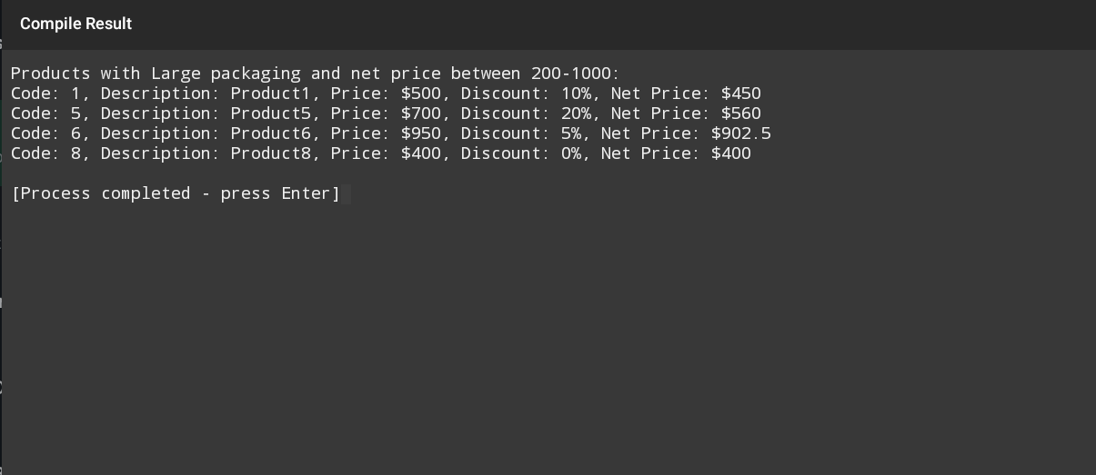

**TASK NO:02**

#include <iostream>

#include <string>

#include <algorithm>

using namespace std;

struct Contact {

    string Name;

    string Address;

    string MobileNumber;

};

int main() {

    Contact contacts[10] = {

        {"Sara", "Street A", "1234567890"},

        {"Saad", "Street B", "9876543210"},

        {"Sarmad", "Street C", "1111111111"},

        {"Ali", "Street D", "2222222222"},

        {"Saima", "Street E", "3333333333"},

        {"Zara", "Street F", "4444444444"},

        {"Sam", "Street G", "5555555555"},

        {"Sana", "Street H", "6666666666"},

        {"Sarah", "Street I", "7777777777"},

        {"John", "Street J", "8888888888"}

    };

    string query;

    cout << "Enter starting letters of the name to search: ";

    cin >> query;

    transform(query.begin(), query.end(), query.begin(), ::tolower);

    cout << "Matching contacts:" << endl;

    for (int i = 0; i < 10; i++) {

        string name = contacts[i].Name;

        transform(name.begin(), name.end(), name.begin(), ::tolower);

        if (name.find(query) == 0) { // Match at the start

            cout << "Name: " << contacts[i].Name

                 << ", Address: " << contacts[i].Address

                 << ", Mobile: " << contacts[i].MobileNumber << endl;

        }

    }

    return 0;

}

**Out put**

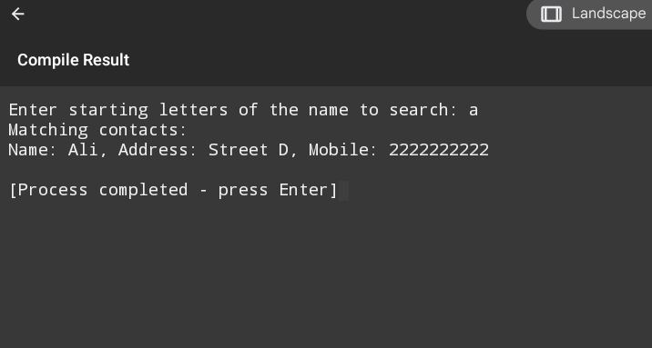

**TASK NO:03**

#include <iostream>

using namespace std;

int findGreatest(int arr[], int size) {

    int max = arr[0];

    for (int i = 1; i < size; i++) {

        if (arr[i] > max) {

            max = arr[i];

        }

    }

    return max;

}

int main() {

    int values[20];

    cout << "Enter 20 integers: " << endl;

    for (int i = 0; i < 20; i++) {

        cin >> values[i];

    }

    int greatest = findGreatest(values, 20);

    cout << "The greatest number is: " << greatest << endl;

    return 0;

}

**Out put:**

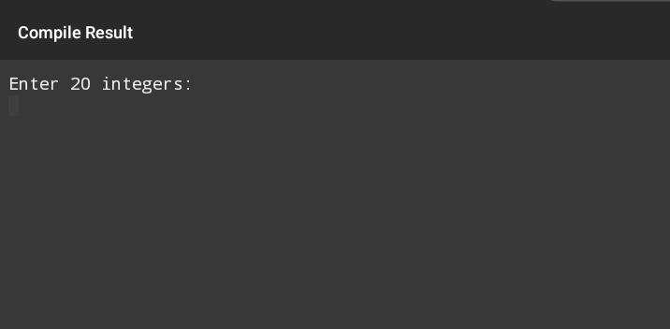

**Task no :04**

#include <iostream>

using namespace std;

int main() {

    float yearlyBudget[5][12]; // Assuming 5 budget items for simplicity

    cout << "Enter the yearly budget for each item and month:" << endl;

    for (int i = 0; i < 5; i++) {

        cout << "Budget item " << i + 1 << ":" << endl;

        for (int j = 0; j < 12; j++) {

            cout << "Month " << j + 1 << ": ";

            cin >> yearlyBudget[i][j];

        }

    }

    cout << "\nYearly budget:" << endl;

    for (int i = 0; i < 5; i++) {

        cout << "Budget item " << i + 1 << ": ";

        for (int j = 0; j < 12; j++) {

            cout << yearlyBudget[i][j] << " ";

        }

        cout << endl;

    }

    return 0;

}

**Out put:**

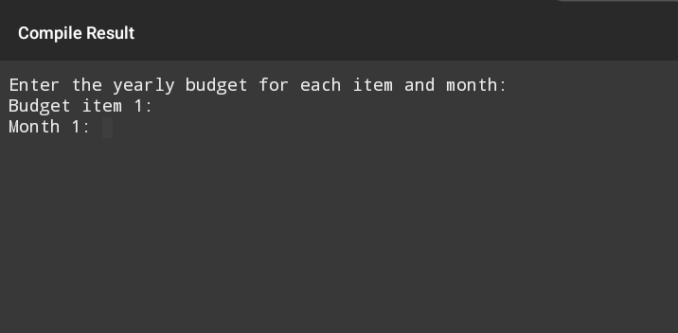

**Task no:05**

#include <iostream>

#include <string>

using namespace std;

struct Currency {

    string Type;

    float ConversionRate; // To USD

};

int main() {

    Currency rupee = {"Rupee", 0.012}; // Example conversion rate

    float amountInUSD;

    cout << "Enter amount in USD: ";

    cin >> amountInUSD;

    float convertedAmount = amountInUSD / rupee.ConversionRate;

    cout << amountInUSD << " USD is equal to " << convertedAmount << " " << rupee.Type << "(s)" << endl;

    return 0;

}

**Out put:**

